EE 97 Fall 2016

Thurs. 1330

Lab #3 Simple Light-Controlled Switch

Sidarth Shahri

Partner: Christian Lopez

Station 10

Submitted 22 September 2016

Lab #3 Simple Light-Controlled Switch

**Experiment 1**

The metal-oxide-semiconductor field-effect-transistor, otherwise known as MOSFET, is a type of transistor used for amplifying or switching electronic signals. The transistor has three pins, a gate, a drain, and a source. The gate is the control signal which can allow current to flow through the source to the drain. There is a certain threshold level Vth that Vgs, the voltage between the gate and source, must reach for the transistor to turn “on” and allow current to flow.

Measurements were made in ENGR 345, Station 10 on September 15, 2016, using the

* Agilent Digital Multimeter 34405A (S/N: TW48090264)
* HP Three Output Power Source E3631A (S/N: KR 90917880)
* Potentiometer CRMT103
* MOSFET IRF640A
* 756 Lamp Bayonet

Experiment Questions:

1. Resistance between D & S: 2.5612 MΩ

Resistance between G & S: 2.5900 MΩ

1. Circuit Constructed:

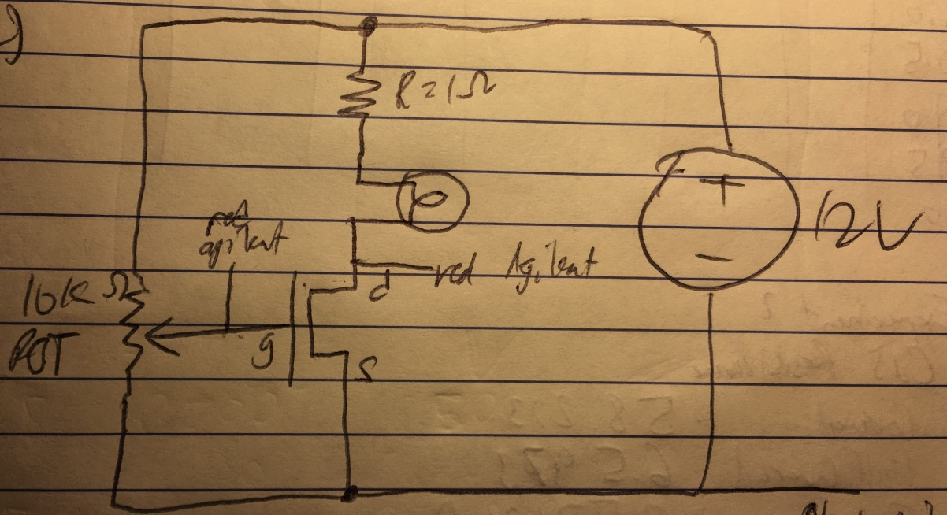

4) Data Table:

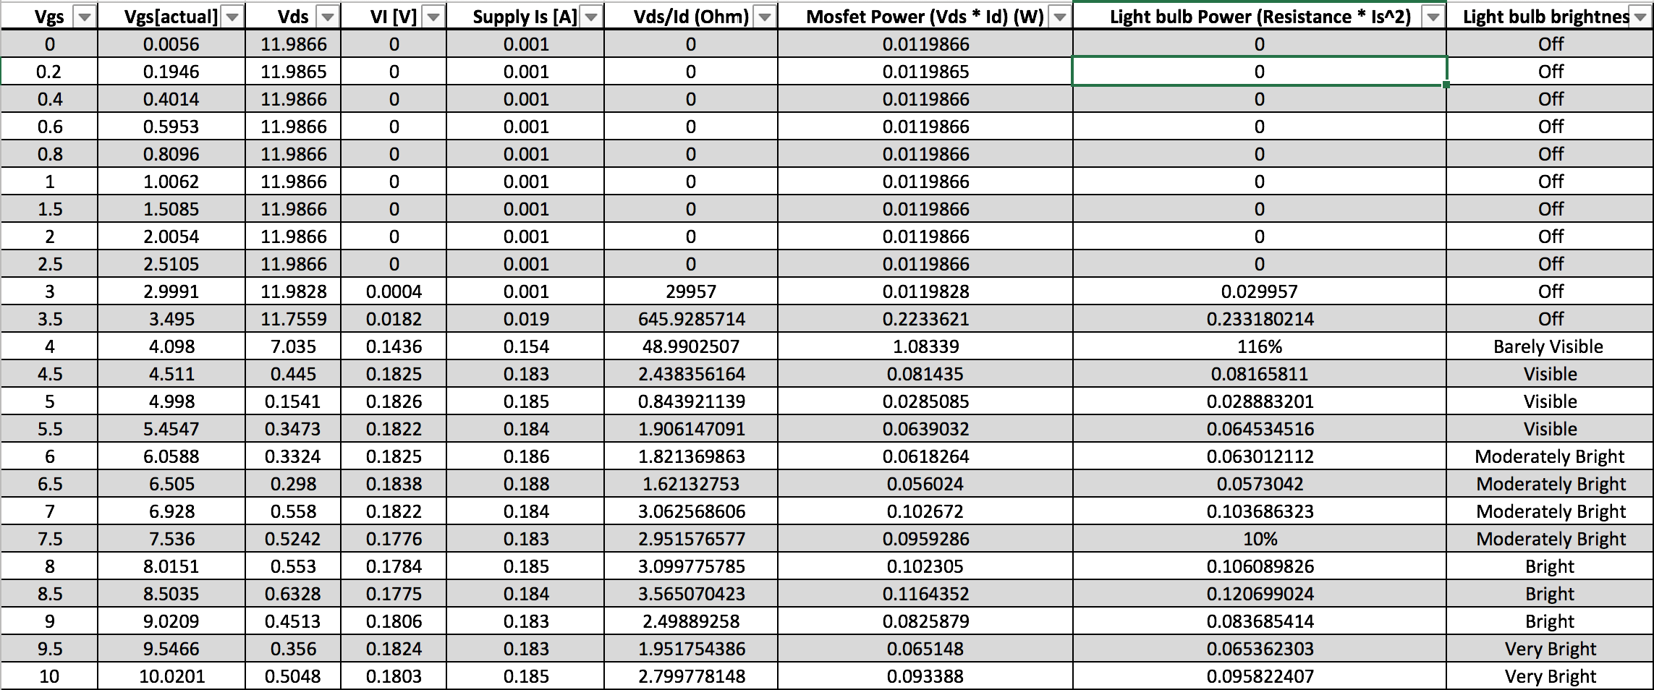

5) VTH is about 3.4 volts.

6)

Conclusion:

The MOSFET transistor makes an ideal switch for this circuit. When the potentiometer in the circuit is turned to a certain point, the Vgs is greater than the threshold voltage needed to turn the transistor on. When this happens, the light bulb can turn on. As the potentiometer’s resistance is further increased, the light bulb gets brighter as more voltage goes to the light bulb.

**Experiment #2**

In this experiment, we used a photoresistor (CdS) to turn a light bulb on or off depending on the amount of ambient light hitting the CdS. The CdS changes its resistance based on how much light hits it. When completely covered or shielded from light, the resistance is extremely low and current passes through it more easily.

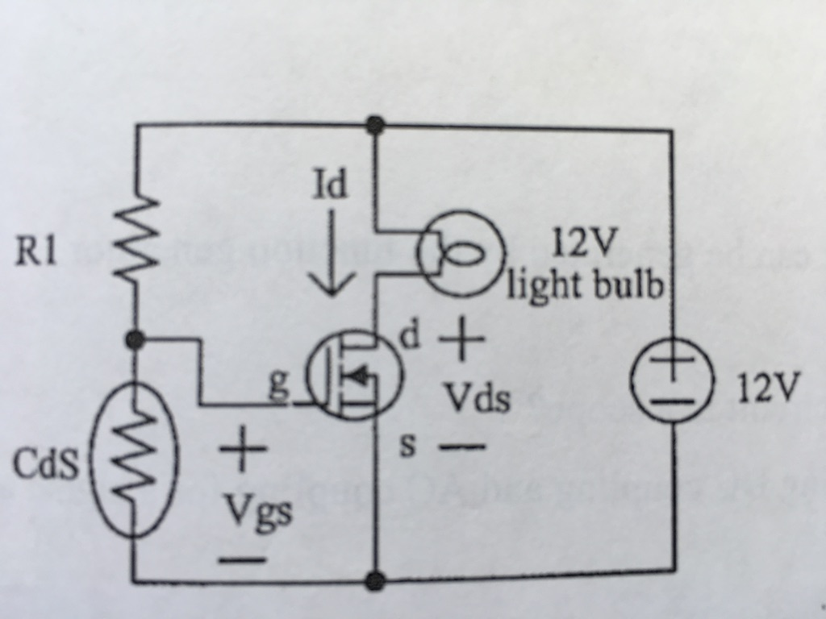

Experminent Data:

CdS Resistance:

* Covered: 58.233Ω
* Half-Covered: 6.5973Ω
* Exposed: 3.5710KΩ

R1 is 9100 Ohms. The value for R1 was determined by the equation below.

Vth = RCdS / (R1 + RCdS) * 12V

Conclusion:

The photoresistor works as expected. When the photoresistor is covered, the light bulb turns on.